Use case diagram

1. Use case diagram: Book Rental System (Overall system)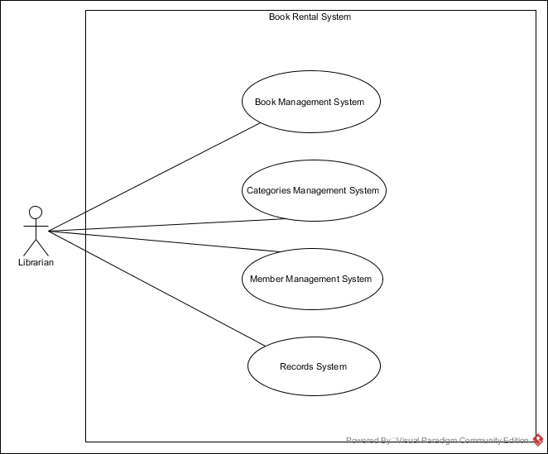
2. 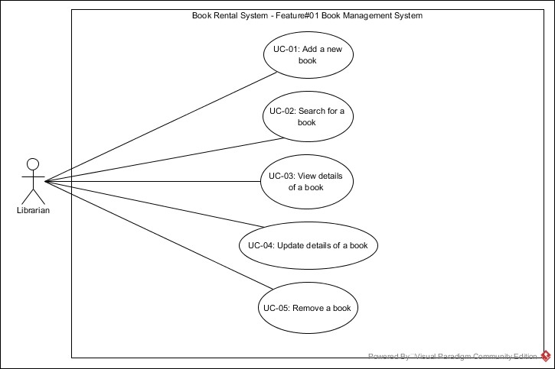Use case diagram (Book Management System)
3. 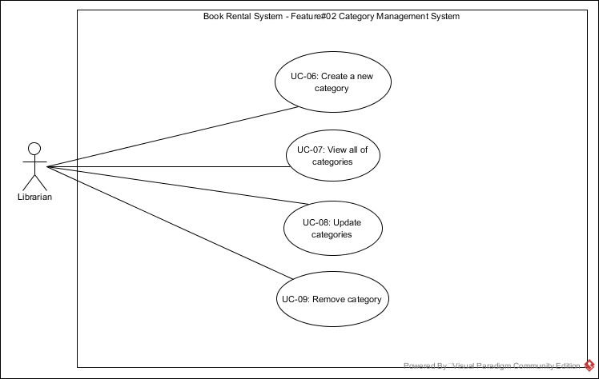Use case diagram (Category Management System)
4. Use case diagram (Member Management System)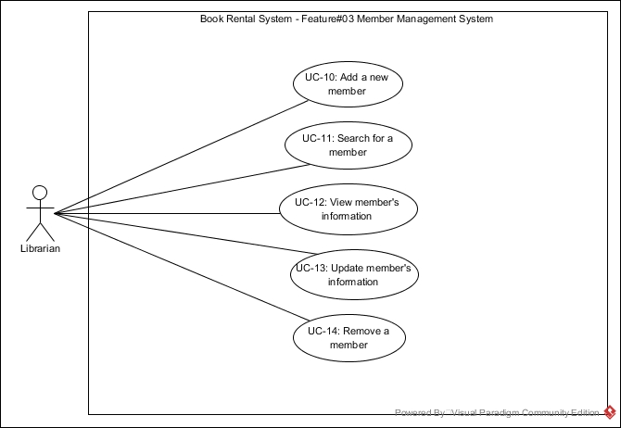
5. Use case diagram (Records System)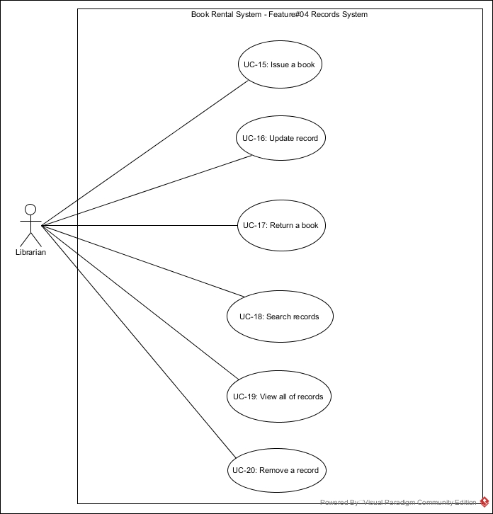

Use case description

And

Activity diagram

|  |  |  |  |  |
| --- | --- | --- | --- | --- |
| Use Case ID | UC-01 | | | |
| Use Case Name | Add a new book | | | |
| Created By | Mr. Pasakorn Kunchai | | Last Update By | Mr. Apiwat Hantrakool |
| Date Created | 15-04-2017 | | Last Revision Date | 23-04-2017 |
| Actors | Librarian | | | |
| Description | The librarian can add a new book into the system using book name, book category, price and author. | | | |
| Trigger | The librarian clicks “Add a new book” button at home page. | | | |
| Preconditions | - | | | |
| Use Case Input Specification | | | | |
| Input | type | Constraint | | Example |
| book name | String | Length must not exceed 50 characters. | | Database |
| category | String | Must have in the database or null. | | Computer |
| price | double | Decimal number with 2 decimal digits. | | 299.00 |
| author | String | Length must not exceed 50 characters. | | Dr. Natee |
| Post conditions | If the use case is successful, the new book is stored in the database. If not the system return to home page | | | |
| Normal Flows | User | | System | |
| 1. |  | | The system shall display the user interface for adding the book consisting of 3 text fields for book name, price and author. And 1 data list for book category. | |
| 2. |  | | The system shall display a button labeled as “Add book”. | |
| 3. | The librarian input information to the text fields. | |  | |
| 4. | The librarian clicks “Add book” button. | |  | |
| 5. |  | | The system shall validate the input. [A1: Text field is empty]. | |
| 6. |  | | The system shall auto generate the book id and book status by the following criteria.   * + book id => count form 1 (numeric input).   + book status => available. | |
| 7. |  | | The system shall add the information of the book including book id, book name, book status, category, price and author into the database. [E1: Database cannot be connected] | |
| 8. |  | | The system shall display the success message “The book is stored in the database”. | |
| Alternative Flow | A1: Text field is empty   * The system shall display the fail message “Text field must not be empty”. * Return to normal flows 3. | | | |
| Exception Flow | E1: Database cannot be connected   * The system shall display the fail message “Fail to connect the database”. * Use case ends. | | | |
| Assumption | The Librarian must understand English. | | | |

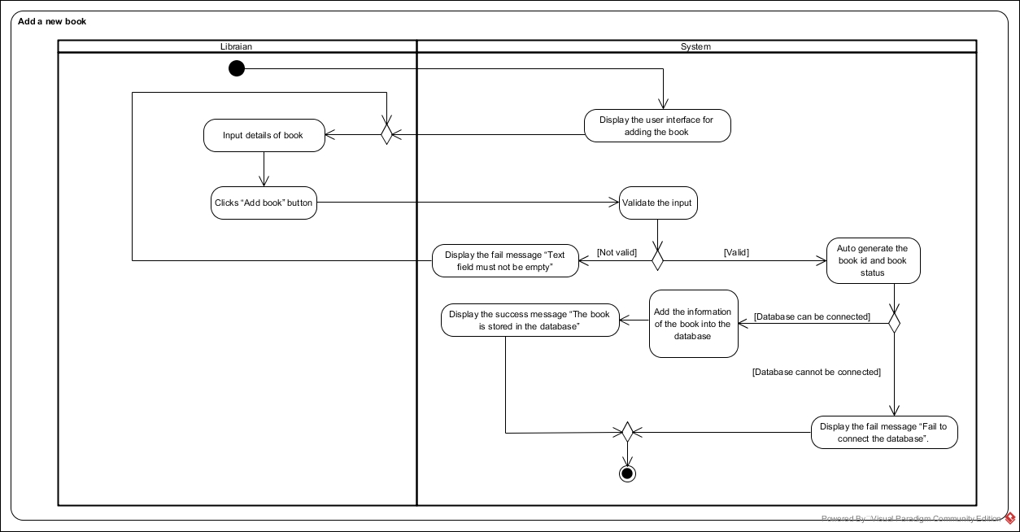Activity diagram: AD-01

|  |  |  |  |  |
| --- | --- | --- | --- | --- |
| Use Case ID | UC-02 | | | |
| Use Case Name | Search a book | | | |
| Created By | Mr. Apiwat Hantrakool | | Last Update By | Mr. Apiwat Hantrakool |
| Date Created | 16-04-2017 | | Last Revision Date | 20-04-2017 |
| Actors | Librarian | | | |
| Description | The librarian can search for a book from the database using keyword and option. | | | |
| Trigger | The librarian clicks “Search book” button at home page. | | | |
| Preconditions | - | | | |
| Use Case Input Specification | | | | |
| Input | type | Constraint | | Example |
| keyword | String | Length must not exceed 50 characters. | | Math for SE |
| option | String | Select one of this set [book id, book name, book status, category, price, author]. | | book status |
| Post conditions | If the use case is successful, at least one book is displayed. If not the system return to home page. | | | |
| Normal Flows | User | | System | |
| 1. |  | | The system shall display the user interface for search the book consisting of 1 text field for keyword. | |
| 2. |  | | The system provides options to search, which are book id, book name, book status, category, price and author. | |
| 3. |  | | The system shall display a button labeled as “Search book.” | |
| 4. | The librarian input keyword to the text field. | |  | |
| 5. | The librarian selects the options. | |  | |
| 6. | The librarian clicks “Search book” button. | |  | |
| 7. |  | | The system shall validate the input. [A1: Text field is empty]. | |
| 8. |  | | The system shall retrieve the list of book using keyword and option in the book id, book name, book status, category, price and author into the database. [A2: Book is not matched] , [E1: Database cannot be connected] ,[E2: There is no book in the database]. | |
| 9. |  | | The system shall display the list of book at least one book that matches with the keyword. | |
| Alternative Flow | A1: Text field is empty   * The system shall display the fail message “Text field must not be empty”. * Return to normal flows 4.   A2: Book is not matched   * The system shall display the message “There is no book matched with the keyword”. * Return to normal flows 4. | | | |
| Exception Flow | E1: Database cannot be connected.   * The system shall display the fail message “Fail to connect the database”. * Use case ends.   E2: There is no book in the database.   * The system shall display the message “There is no book in the database”. * Use case ends. | | | |
| Assumption | The Librarian must understand English. | | | |

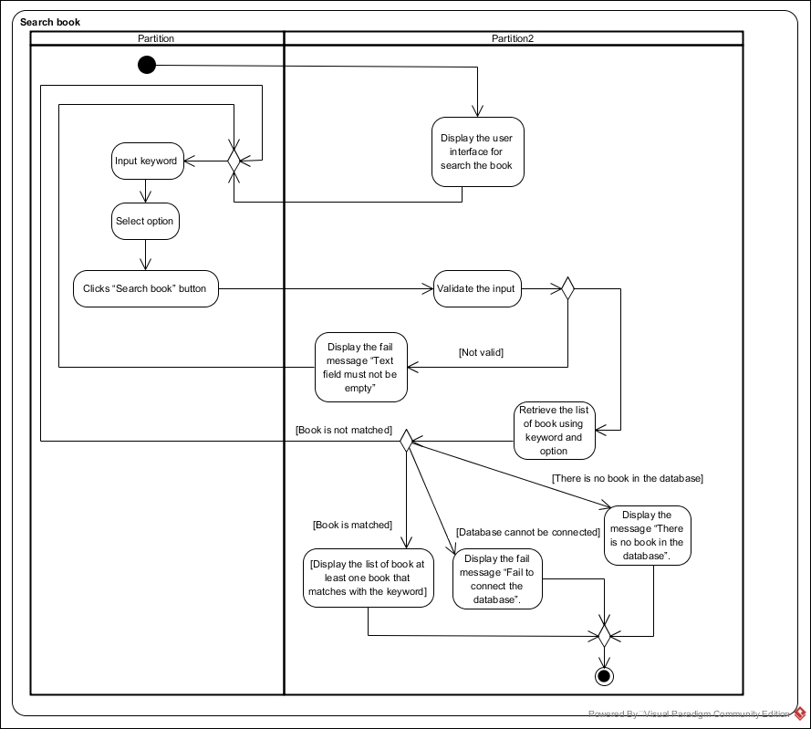Activity diagram: AD-02

|  |  |  |  |  |
| --- | --- | --- | --- | --- |
| Use Case ID | UC-03 | | | |
| Use Case Name | View details of book. | | | |
| Created By | Mr. Apiwat Hantrakool | | Last Update By | Mr. Apiwat Hantrakool |
| Date Created | 16-04-2017 | | Last Revision Date | 22-04-2017 |
| Actors | Librarian | | | |
| Description | The librarian can view details of book. | | | |
| Trigger | The librarian clicks “View details” button next to the book name. | | | |
| Preconditions | The librarian found the book by searching. | | | |
| Use Case Input Specification | | | | |
| Input | type | Constraint | | Example |
| - | - | - | | - |
| Post conditions | If the use case is successful, the details of the book are displayed. If not the system return to home page. | | | |
| Normal Flows | User | | System | |
| 1. |  | | The system shall provide a button labeled as “View details” for the librarian to view the details of a book. | |
| 2. | The librarian clicks “View details” button. | |  | |
| 3. |  | | The system shall be able to get the details of a book from the database. [E1: Database cannot be connected] | |
| 4. |  | | The system shall provide an interface, which displays the book id, book name, book status, category, price and author. | |
| Alternative Flow | - | | | |
| Exception Flow | E1: Database cannot be connected.   * The system shall display the fail message “Fail to connect the database”. * Use case ends. | | | |
| Assumption | The Librarian must understand English. | | | |

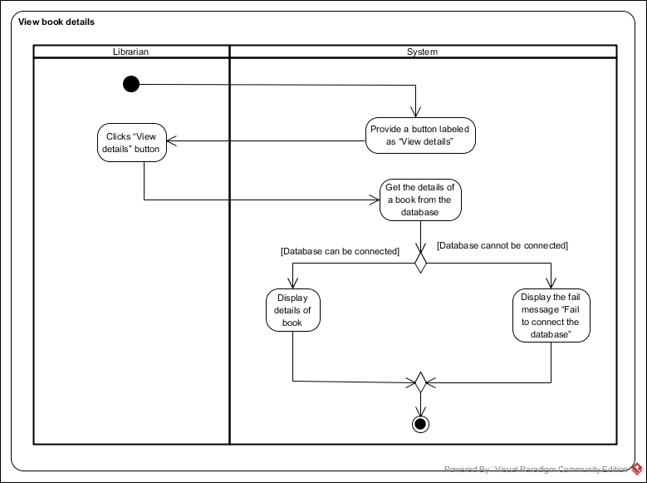Activity diagram: AD-03

|  |  |  |  |  |
| --- | --- | --- | --- | --- |
| Use Case ID | UC-04 | | | |
| Use Case Name | Update details of book. | | | |
| Created By | Mr. Apiwat Hantrakool | | Last Update By | Mr. Apiwat Hantrakool |
| Date Created | 16-04-2017 | | Last Revision Date | 23-04-2017 |
| Actors | Librarian. | | | |
| Description | The library can update details of a book, which are book name, category, price, author and book status. | | | |
| Trigger | The librarian clicks “Update book” button next to the book name. | | | |
| Preconditions | The librarian found the book by searching. | | | |
| Use Case Input Specification | | | | |
| Input | type | Constraint | | Example |
| book name | String | String of length 50. | | Object oriented programming. |
| category | String | Data list (list of categories that was created) or null. | | Computer |
| price | Double | Decimal number with 2 decimal digits. | | 300.25 |
| author | String | String of length 50. | | Dr. Prompong |
| book status | String | Select one of this set [borrowed, available, disappeared, corrupted, removed]. | | borrowed |
| Post conditions | If the use case is successful, the details of book are updated to the database. If not the system return to home page. | | | |
| Normal Flows | User | | System | |
| 1. |  | | The system displays the user interface for updating the book consisting 3 text fields, which are book name, price, and author. And consisting 2 data lists, which is category and book status. | |
| 2. |  | | The system shall display a button labeled as “Update book”. | |
| 3. | The librarian input information to every text fields. | |  | |
| 4. | The librarian clicks “Update book” button. | |  | |
| 5. |  | | The system shall validate the input. [A1: Text field is empty] | |
| 6. |  | | The system shall display a confirmation box with message “Are you confirm to update this book” and “Yes” button and “No” button. | |
| 7. | The librarian clicks “Yes” button. [E1: clicks “No” button] | |  | |
| 8. |  | | The system shall update the information of the book into the database. [E2: Database cannot be connected] | |
| 9. |  | | The system shall display the success message “The input is stored in the database”. | |
| Alternative Flow | A1: Text field is empty.   * The system shall display the fail message “Text field must not be empty”. * Return to normal flows 3. | | | |
| Exception Flow | E1: Clicks “No” button.   * Use case ends.   E2: Database cannot be connected.   * The system shall display the fail message “Fail to connect the database” * Use case ends. | | | |
| Assumption | The librarian must understand English. | | | |

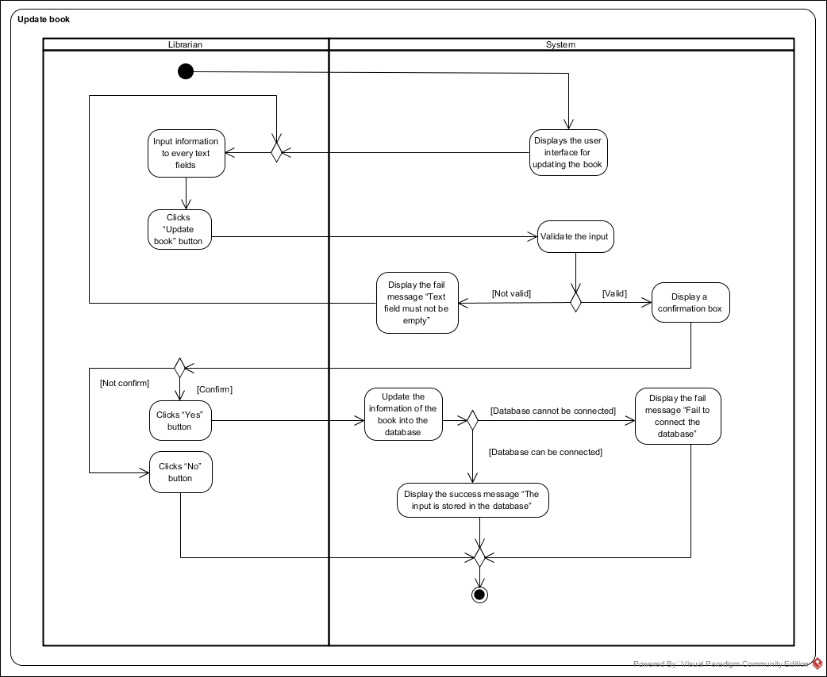Activity diagram: AD-04

|  |  |  |  |  |
| --- | --- | --- | --- | --- |
| Use Case ID | UC-05 | | | |
| Use Case Name | Remove a book. | | | |
| Created By | Mr. Apiwat Hantrakool | | Last Update By | Mr. Apiwat Hantrakool |
| Date Created | 17-04-2017 | | Last Revision Date | 22-04-2017 |
| Actors | Librarian | | | |
| Description | The librarian can remove a book from the shop. | | | |
| Trigger | The librarian clicks “Delete book” button next to the book name. | | | |
| Preconditions | The librarian found the book by searching. | | | |
| Use Case Input Specification | | | | |
| Input | type | Constraint | | Example |
| - | - | - | | - |
| Post conditions | If the use case is successful, the status of the book is update to “removed”. If not the system return to home page. | | | |
| Normal Flows | User | | System | |
| 1. |  | | The system shall display a button labeled as “Delete book” next to the book name. | |
| 2. | The librarian clicks “Delete book” button. | |  | |
| 3. |  | | The system shall display a confirmation box with message “Are you confirm to deleted this book” and “Yes” button and “No” button. | |
| 4. | The librarian clicks “Yes” button. [E1: clicks “No” button] | |  | |
| 5. |  | | The system shall update the book status to “removed”. [E2: Database cannot be connected] | |
| Alternative Flow | - | | | |
| Exception Flow | E1: Clicks “No” button.   * Use case ends.   E2: Database cannot be connected.   * The system shall display the fail message “Fail to connect the database”. * Use case ends. | | | |
| Assumption | The librarian must understand English. | | | |

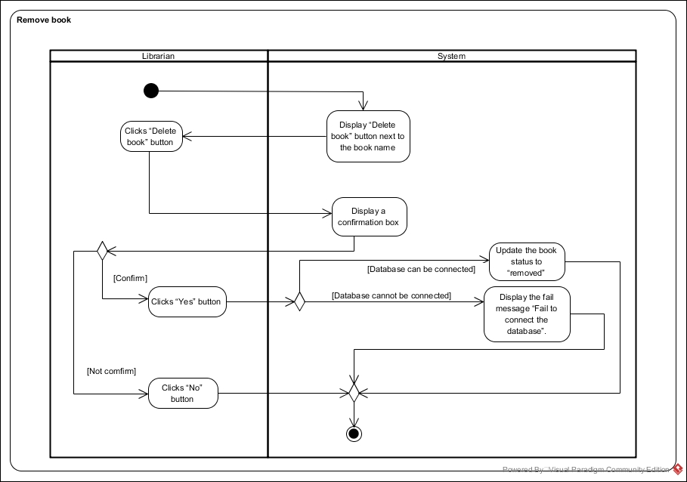Activity diagram: AD-05

|  |  |  |  |  |
| --- | --- | --- | --- | --- |
| Use Case ID | UC-06 | | | |
| Use Case Name | Create a new category. | | | |
| Created By | Mr. Apiwat Hantrakool | | Last Update By | Mr.Apiwat Hantrakool |
| Date Created | 17-04-2017 | | Last Revision Date | 22-04-2017 |
| Actors | Librarian | | | |
| Description | The librarian can create a new category into the system using category name. | | | |
| Trigger | The librarian clicks “Create category” button at home page. | | | |
| Preconditions | - | | | |
| Use Case Input Specification | | | | |
| Input | type | Constraint | | Example |
| category name | String | String of length 20. | | Math |
| Post conditions | If the use case is successful, the category is stored in the database. If not the system return to home page | | | |
| Normal Flows | User | | System | |
| 1. |  | | The system shall display the user interface for adding the category consisting of 1 text field for category name. | |
| 2. |  | | The system shall display a button labeled as “Create category.” | |
| 3. | The librarian input information to text field. | |  | |
| 4. | The librarian clicks “Create category” button. | |  | |
| 5. |  | | The system shall validate the input. [A1: Text field is empty] | |
| 6. |  | | The system shall auto generate the category id and category status by the following criteria.   * + category id => count from 1 (numeric input).   + category status => active. | |
| 7. |  | | The system shall add the information of the category including category id, category name and category status into the database. [E1: Database cannot be connected.] | |
| 8. |  | | The system shall display the success message “The category is stored in the database”. | |
| Alternative Flow | A1: Text field is empty   * The system shall display the fail message “Text field must not be empty”. * Return to normal flows 3. | | | |
| Exception Flow | E1: Database cannot be connected.   * The system shall display the fail message “Fail to connect the database”. * Use case ends. | | | |
| Assumption | The librarian must understand English. | | | |

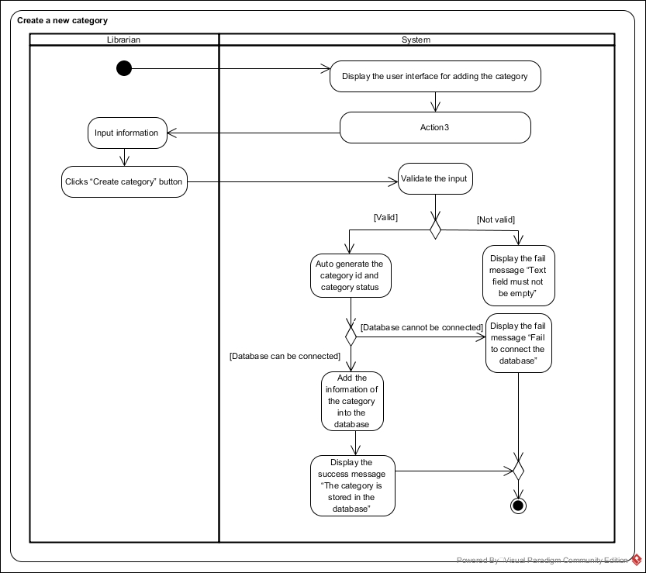Activity diagram: AD-06

|  |  |  |  |  |
| --- | --- | --- | --- | --- |
| Use Case ID | UC-07 | | | |
| Use Case Name | View categories. | | | |
| Created By | Mr. Apiwat Hantrakool | | Last Update By | Mr. Apiwat Hantrakool |
| Date Created | 17-04-2017 | | Last Revision Date | 22-04-2017 |
| Actors | The librarian | | | |
| Description | The librarian can view all of categories in the system. | | | |
| Trigger | The librarian clicks “View categories” button at home page. | | | |
| Preconditions | - | | | |
| Use Case Input Specification | | | | |
| Input | type | Constraint | | Example |
| - | - | - | | - |
| Post conditions | If the use case is successful, the list of categories is displayed. If not the system return to home page. | | | |
| Normal Flows | User | | System | |
| 1. |  | | The system shall be able to get the list of categories from the database [E1: there are not categories in the database.]  , [E2: Database cannot be connected.] | |
| 2. |  | | The system shall provide an interface, which displays category id, category name and category status. | |
| Alternative Flow | - | | | |
| Exception Flow | E1: there are not categories in the database.   * The system shall display “There are not categories in the database” message. * Use case ends.   E2: Database cannot be connected.   * The system shall display the fail message “Fail to connect the database”. * Use case ends. | | | |
| Assumption | The librarian must understand English. | | | |

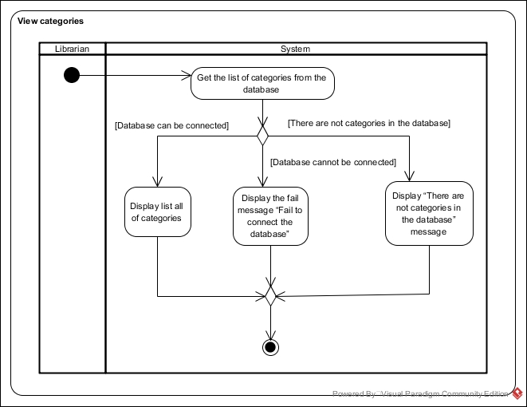Activity diagram: AD-07

|  |  |  |  |  |
| --- | --- | --- | --- | --- |
| Use Case ID | UC-08 | | | |
| Use Case Name | Update category | | | |
| Created By | Mr. Apiwat Hantrakool | | Last Update By | Mr. Apiwat Hantrakool |
| Date Created | 17-04-2017 | | Last Revision Date | 23-04-2017 |
| Actors | Librarian | | | |
| Description | The librarian can update category in the system, which are category name and category status. | | | |
| Trigger | The librarian clicks “Update category” button next to the category name. | | | |
| Preconditions | The librarian clicked view all of categories at homepage. | | | |
| Use Case Input Specification | | | | |
| Input | type | Constraint | | Example |
| category name | String | string of length 20. | | Biology |
| category status | String | [active, not active] | | active |
| Post conditions | If the use case is successful, the details of category are updated to the database. If not the system return to home page. | | | |
| Normal Flows | User | | System | |
| 1. |  | | The system displays the user interface for updating the book consisting 1 text field, which are category name. And 1 data list, which is category status. | |
| 2. |  | | The system shall display a button labeled as “Update category”. | |
| 3. | The librarian input to text field and data list. | |  | |
| 4. | The librarian click “Update category” button. | |  | |
| 5. |  | | The system shall validate the input. [A1: Text field is empty] | |
| 6. |  | | The system shall display a confirmation box with message “Are you confirm to update this category” and “Yes” button and “No” button. | |
| 7. | The librarian click “Yes” button. [E1: Click “No” button] | |  | |
| 8. |  | | The system shall update the information of the category including category name and category status into the database. | |
| 9. |  | | The system shall display the success message “The input is stored in the database”. [E2: Database cannot be connected] | |
| Alternative Flow | A1: Text field is empty.   * The system shall display the fail message “Text field must not be empty”. * Return to normal flows 3. | | | |
| Exception Flow | E1: click “No” button.   * Use case ends.   E2: Database cannot be connected.   * The system shall display the fail message “Fail to connect the database”. * Use case ends. | | | |
| Assumption | The librarian must understand English. | | | |

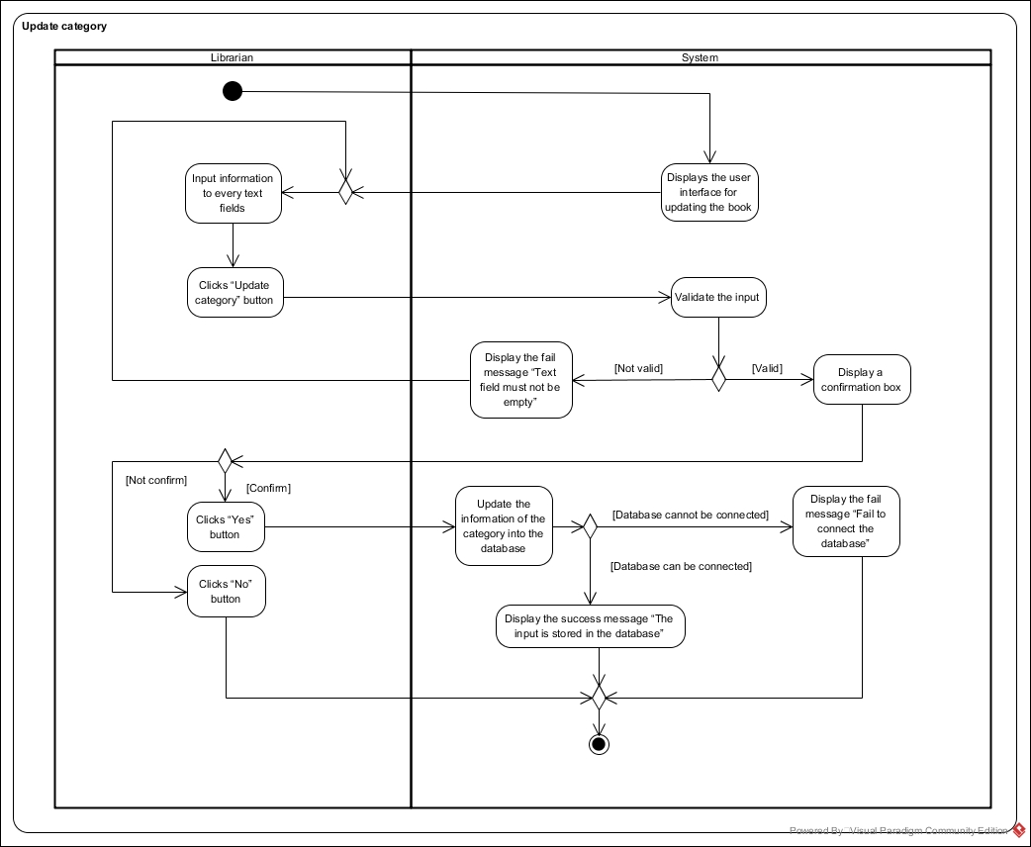Activity diagram: AD-08

|  |  |  |  |  |
| --- | --- | --- | --- | --- |
| Use Case ID | UC-09 | | | |
| Use Case Name | Remove category. | | | |
| Created By | Mr. Apiwat Hantrakool | | Last Update By | Mr. Apiwat Hantrakool |
| Date Created | 17-04-2017 | | Last Revision Date | 22-04-2017 |
| Actors | Librarian. | | | |
| Description | The librarian can remove category. | | | |
| Trigger | The librarian clicks “Delete category” button next to the category name. | | | |
| Preconditions | The librarian clicked view all of categories at home page. | | | |
| Use Case Input Specification | | | | |
| Input | type | Constraint | | Example |
| - | - | - | | - |
| Post conditions | If the use case is successful, the status of the category is updated to “not active”. If not the system return to home page | | | |
| Normal Flows | User | | System | |
| 1. |  | | The system shall display a button labeled as “Delete category” next to the category name. | |
| 2. | The librarian clicks “Delete category” button. | |  | |
| 3. |  | | The system shall display a confirmation box with message “Are you confirm to deleted this category” and “Yes” button and “No” button. | |
| 4. | The librarian click “Yes” button. [E1: clicks “No” button] | |  | |
| 5. |  | | The system shall update the category status to “not active”. [E2: Database cannot be connected] | |
| Alternative Flow | - | | | |
| Exception Flow | E1: Clicks “No” button.   * Use case ends.   E2: Database cannot be connected.   * The system shall display the fail message “Fail to connect the database”. * Use case ends. | | | |
| Assumption | The librarian must understand English. | | | |

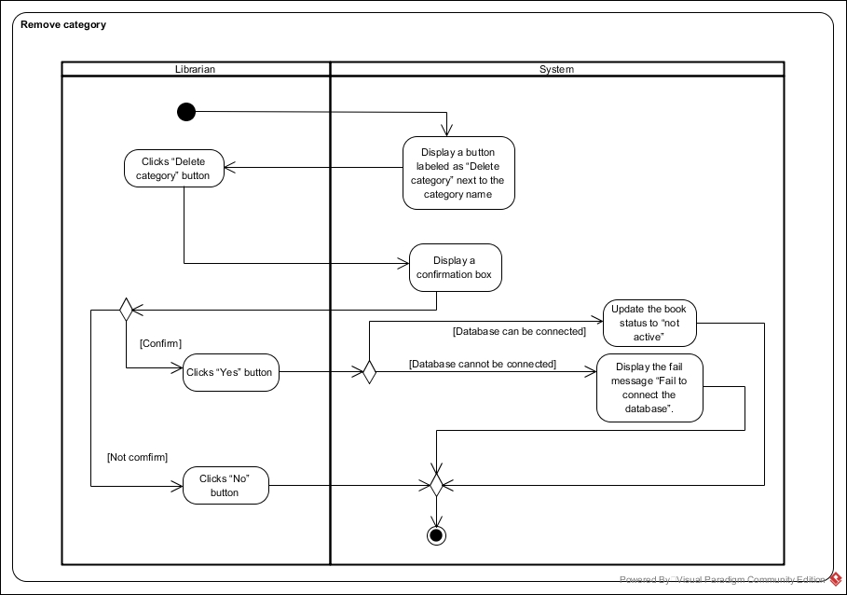Activity diagram: AD-09

|  |  |  |  |  |
| --- | --- | --- | --- | --- |
| Use Case ID | UC-10 | | | |
| Use Case Name | Add new member. | | | |
| Created By | Mr. Apiwat Hantrakool | | Last Update By | Mr. Apiwat Hantrakool |
| Date Created | 17-04-2017 | | Last Revision Date | 22-04-2017 |
| Actors | Librarian | | | |
| Description | The librarian can add a new member into the system using member name, citizen id, and telephone number. | | | |
| Trigger | The librarian clicks “Add member” button at home page. | | | |
| Preconditions | - | | | |
| Use Case Input Specification | | | | |
| Input | type | Constraint | | Example |
| member name | String | String of length 50. | | Apiwat Hantrakool |
| citizen id | int | Numeric input only. | | 1579900690678 |
| telephone | int | Numeric input only. | | 0875652347 |
| Post conditions | If the use case is successful, the information of member is inserted into the database. If not the system return to home page. | | | |
| Normal Flows | User | | System | |
| 1. |  | | The system shall display the user interface for adding the member consisting of 3 text fields for member name, citizen id and telephone number. | |
| 2. |  | | The system shall display a button labeled as “Add member”. | |
| 3. | The librarian input member name, citizen id and telephone number to 3 text fields. | |  | |
| 4. | The librarian clicks “Add member” button. | |  | |
| 5. |  | | The system shall validate the input. [A1: Text field is empty] | |
| 6. |  | | The system shall auto generate the member id and member status by the following criteria.   * + member id => count form 1 (numeric input).   + member status => active. | |
| 7. |  | | The system shall add the information of the member including member id, member name, citizen id, telephone number and member status into the database. [E1: Database cannot be connected. | |
| 8. |  | | The system shall display the success message “The member is stored in the database”. | |
| Alternative Flow | A1: Text field is empty   * The system shall display the fail message “Text field must not be empty”. * Return to normal flows 3. | | | |
| Exception Flow | E1: Database cannot be connected.   * The system shall display the fail message “Fail to connect the database”. * Use case ends. | | | |
| Assumption | The librarian must understand English. | | | |

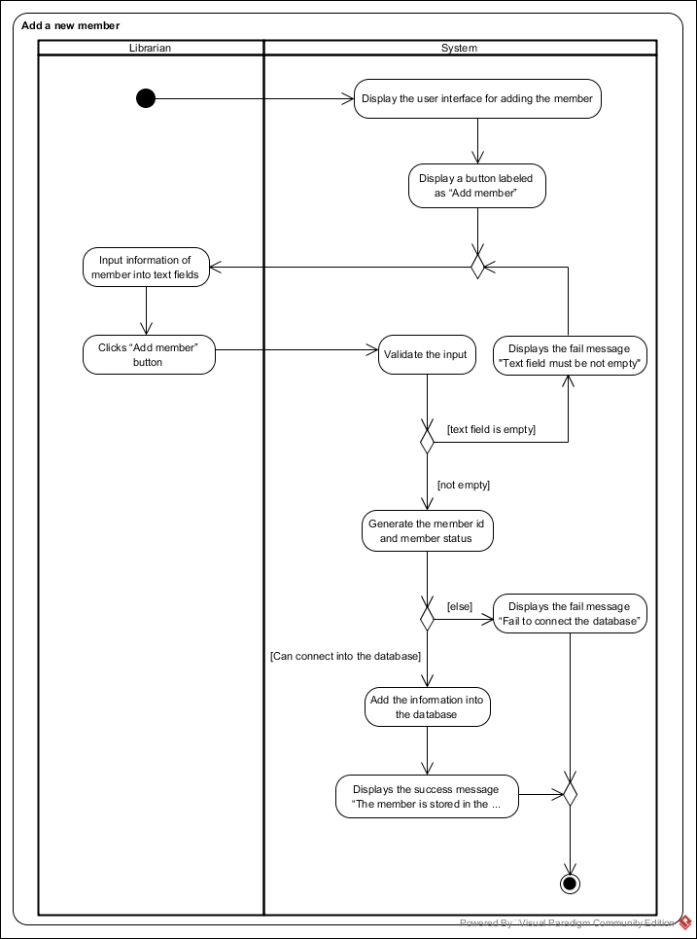Activity diagram: AD-10

|  |  |  |  |  |
| --- | --- | --- | --- | --- |
| Use Case ID | UC-11 | | | |
| Use Case Name | Search member. | | | |
| Created By | Mr. Apiwat Hantrakool | | Last Update By | Mr. Apiwat Hantrakool |
| Date Created | 17-04-2017 | | Last Revision Date | 21-04-2017 |
| Actors | Librarian. | | | |
| Description | The librarian can search for a member from the database using keyword and option. | | | |
| Trigger | The librarian clicks “Search member” button at home page. | | | |
| Preconditions | - | | | |
| Use Case Input Specification | | | | |
| Input | type | Constraint | | Example |
| keyword | String | the length of the keyword. It must not exceed 50 characters. | | Kanatip |
| options | String | [member id, member name, citizen id, telephone number, member status] | | member id |
| Post conditions | If the use case is successful, the list of member is displayed to librarian. If not the system return to home page. | | | |
| Normal Flows | User | | System | |
| 1. |  | | The system shall provide options to search, which is member id, member name, citizen id, telephone number and member status. | |
| 2. |  | | The system shall display the user interface for search the member consisting of 1 text field for keyword. | |
| 3. |  | | The system shall display a button labeled as “Search member”. | |
| 4. | The librarian input keyword to text field. | |  | |
| 5. | The librarian select the options. | |  | |
| 6. | The librarian click “Search member” button. | |  | |
| 7. |  | | The system shall validate the input. [A1: keyword is wrong in format] | |
| 8. |  | | The system shall retrieve the list of member using keyword and option in the is member id, member name, citizen id, telephone number and member status into the database. [A2: member is not matched], [E1: Database cannot be connected], [E2: There is no member in the database] | |
| 9. |  | | The system shall display the list of member at least one member that matches with the keyword. | |
| Alternative Flow | A1: keyword is wrong in format.   * The system shall display the fail message next to the keyword text fields “The format of keyword is not valid”. * Return to normal flows 4.   A2: Book is not matched   * The system shall display the message “There is no member matched with the keyword”. * Return to normal flows 4. | | | |
| Exception Flow | E1: Database cannot be connected.   * The system shall display the fail message “Fail to connect the database”. * Use case ends.   E2: There is no member in the database.   * The system shall display the message “There is no member in the database”. * Use case ends. | | | |
| Assumption | The Librarian must understand English. | | | |

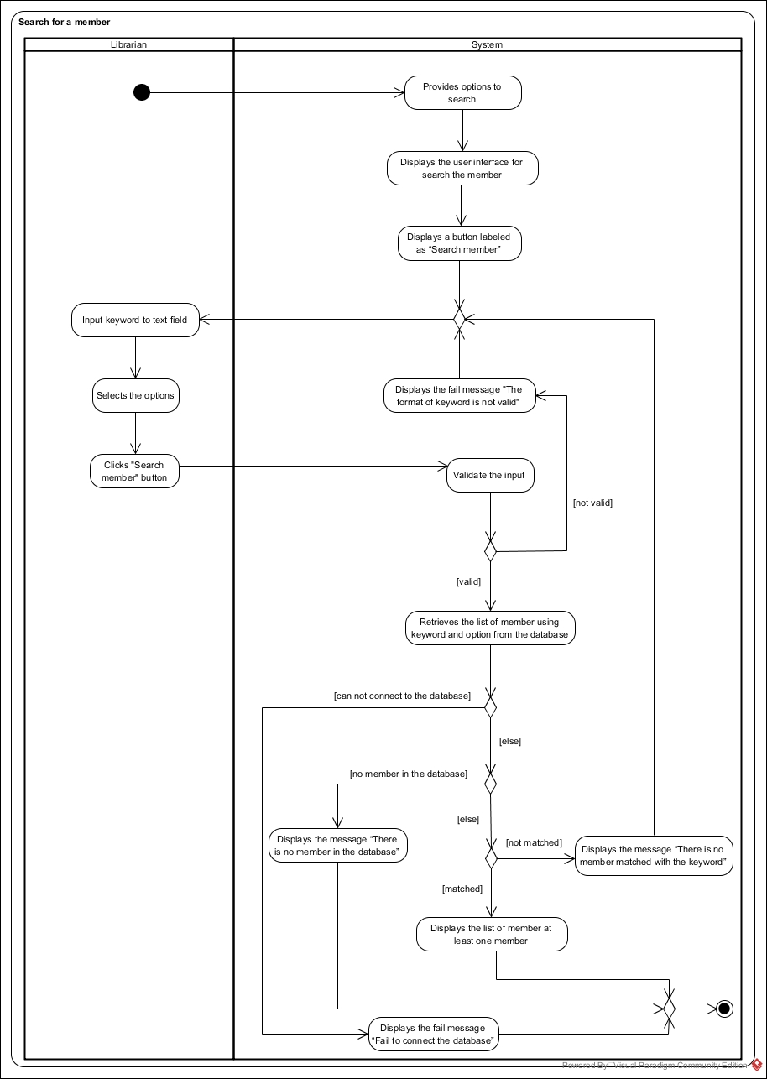Activity diagram: AD-11

|  |  |  |  |  |
| --- | --- | --- | --- | --- |
| Use Case ID | UC-12 | | | |
| Use Case Name | View information of member. | | | |
| Created By | Mr. Apiwat Hantrakool | | Last Update By | Mr. Apiwat Hantrakool |
| Date Created | 17-04-2017 | | Last Revision Date | 22-04-2017 |
| Actors | Librarian | | | |
| Description | The librarian can view information of member. | | | |
| Trigger | The librarian clicks “View information” button next to the member name. | | | |
| Preconditions | The librarian found the member by searching. | | | |
| Use Case Input Specification | | | | |
| Input | type | Constraint | | Example |
| - | - | - | | - |
| Post conditions | If the use case is successful, the information of the member is displayed. If not the system return to home page. | | | |
| Normal Flows | User | | System | |
| 1. |  | | The system shall provide a button labeled as “View information” for the librarian to view the member’s information in the system. | |
| 2. | The librarian clicks “View information” button. | |  | |
| 3. |  | | The system shall be able to get the information of member from the database. [E1: Database cannot be connected] | |
| 4. |  | | The system shall provide an interface, which displays member id, member name, citizen id, telephone number and member status. | |
| Alternative Flow | - | | | |
| Exception Flow | E1: Database cannot be connected.   * The system shall display the fail message “Fail to connect the database” if the database cannot be connected. * Use case ends. | | | |
| Assumption | The Librarian must understand English. | | | |

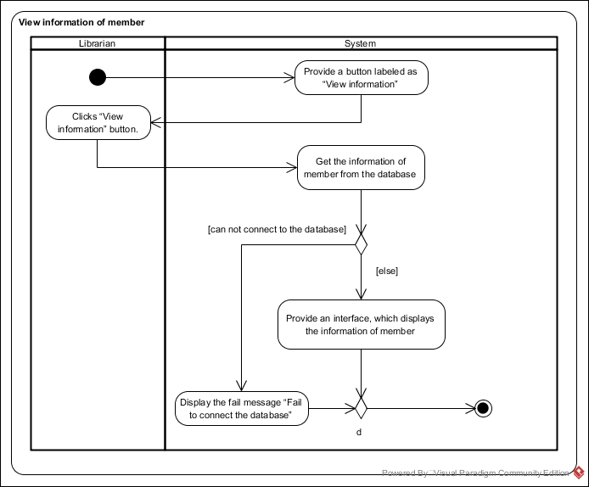Activity diagram: AD-12

|  |  |  |  |  |
| --- | --- | --- | --- | --- |
| Use Case ID | UC-13 | | | |
| Use Case Name | Update information of member. | | | |
| Created By | Mr. Apiwat Hantrakool | | Last Update By | Mr. Apiwat Hantrakool |
| Date Created | 16-04-2017 | | Last Revision Date | 23-04-2017 |
| Actors | Librarian. | | | |
| Description | The library can update details of a member, which are member name, citizen id, member status and telephone number. | | | |
| Trigger | The librarian clicks “Update member” button next to the information of member. | | | |
| Preconditions | The librarian found the member by searching. | | | |
| Use Case Input Specification | | | | |
| Input | type | Constraint | | Example |
| member name | String | String of length 50. | | Apiwat Hantrakool |
| citizen id | int | Numeric input only. | | 1579900690678 |
| telephone | int | Numeric input only. | | 0875652347 |
| member status | String | Select one of this set [active, not active] | | active |
| Post conditions | If the use case is successful, the information of member is updated into the database. If not the system return to home page. | | | |
| Normal Flows | User | | System | |
| 1. |  | | The system displays the user interface for updating the member consisting 3 text fields, which are member name, citizen id and telephone. And 1 data list which is member status. | |
| 2. |  | | The system shall display a button labeled as “Update member”. | |
| 3. | The librarian input information to every text fields and data list. | |  | |
| 4. | The librarian clicks “Update member” button. | |  | |
| 5. |  | | The system shall validate the input. [A1: Text field is empty] | |
| 6. |  | | The system shall display a confirmation box with message “Are you confirm to update this member” and “Yes” button and “No” button. | |
| 7. | The librarian click “Yes” button. [E1: Clicks “No” button] | |  | |
| 8. |  | | The system shall update the information of the member into the database. [E2: Database cannot be connected] | |
| 9. |  | | The system shall display the success message “The input is stored in the database”. | |
| Alternative Flow | A1: Text field is empty.   * The system shall display the fail message “Text field must not be empty”. * Return to normal flows 3. | | | |
| Exception Flow | E1: Click “No” button.   * Use case ends.   E2: Database cannot be connected.   * The system shall display the fail message “Fail to connect the database” if the database cannot be connected. * Use case ends. | | | |
| Assumption | The librarian must understand English. | | | |

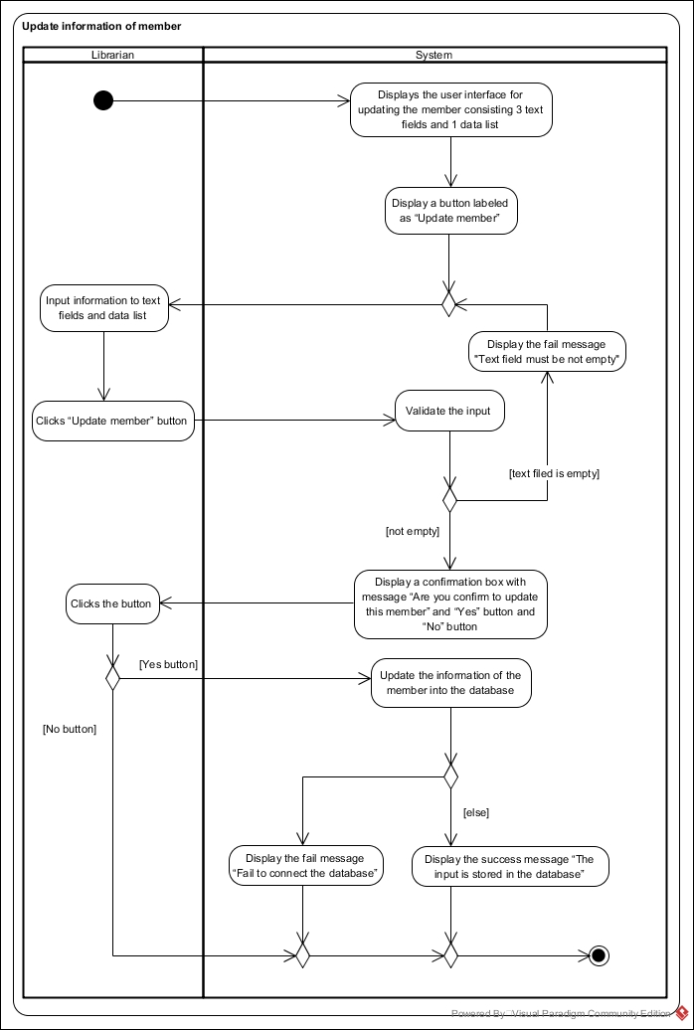Activity diagram: AD-13

|  |  |  |  |  |
| --- | --- | --- | --- | --- |
| Use Case ID | UC-14 | | | |
| Use Case Name | Remove a member. | | | |
| Created By | Mr. Apiwat Hantrakool | | Last Update By | Mr. Apiwat Hantrakool |
| Date Created | 17-04-2017 | | Last Revision Date | 22-04-2017 |
| Actors | Librarian | | | |
| Description | The librarian can remove a member. | | | |
| Trigger | The librarian clicks “Delete member” button next to the member name. | | | |
| Preconditions | The librarian found the member by searching. | | | |
| Use Case Input Specification | | | | |
| Input | type | Constraint | | Example |
| - | - | - | | - |
| Post conditions | If the use case is successful, the status of the member is update to “not active”. If not the system return to home page | | | |
| Normal Flows | User | | System | |
| 1. |  | | The system shall display a button labeled as “Delete member” next to the member name. | |
| 2. | The librarian clicks “Delete member” button. | |  | |
| 3. |  | | The system shall display a confirmation box with message “Are you confirm to deleted this member” and “Yes” button and “No” button. | |
| 4. | The librarian clicks “Yes” button. [E1: click “No” button] | |  | |
| 5. |  | | The system shall update the member status to “not active”. [E2: Database cannot be connected] | |
| Alternative Flow | - | | | |
| Exception Flow | E1: Click “No” button.   * Use case ends.   E2: Database cannot be connected.   * The system shall display the fail message “Fail to connect the database”. * Use case ends. | | | |
| Assumption | The librarian must understand English. | | | |

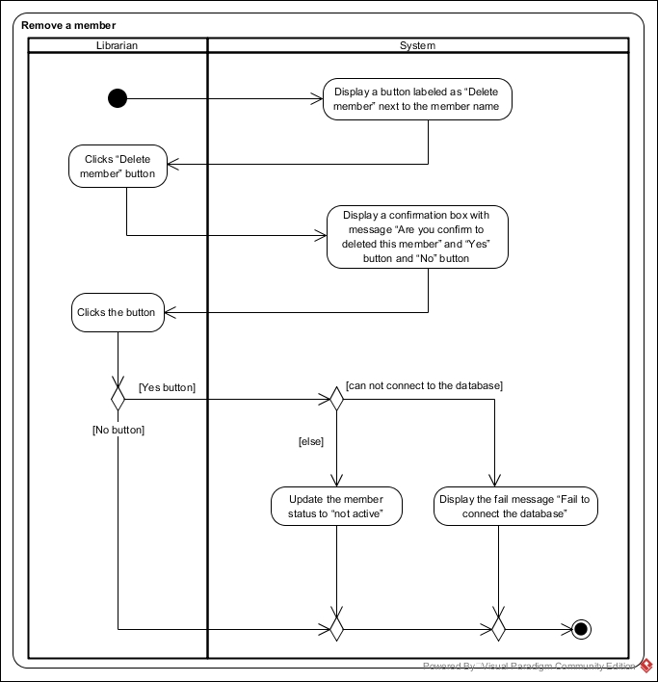Activity diagram: AD-14

|  |  |  |  |  |
| --- | --- | --- | --- | --- |
| Use Case ID | UC-15 | | | |
| Use Case Name | Issue a book | | | |
| Created By | Mr. Pasakorn Kunchai | | Last Update By | Mr. Pasakorn Kunchai |
| Date Created | 15-04-2017 | | Last Revision Date | 22-04-2017 |
| Actors | Librarian | | | |
| Description | The librarian can issue a book using member id and book id. | | | |
| Trigger | The librarian clicks “Issue a book” button. | | | |
| Preconditions | - | | | |
| Use Case Input Specification | | | | |
| Input | type | Constraint | | Example |
| member id  book id | String  String | Numeric input.  Numeric input | | 214  1028 |
| Post conditions | If the use case is successful,   * The Records in the database is created. * Status of the book is updated to “borrowed”.   If not the system return to home page | | | |
| Normal Flows | User | | System | |
| 1. |  | | The system shall display the user interface for issue the book consisting of 1 text fields for member id. | |
| 2. |  | | The system shall provide a button labeled as “Confirm member” for the librarian to validate the member id. | |
| 3. | The librarian input member id to the text fields. | |  | |
| 4. | The librarian clicks “Confirm member” button. | |  | |
| 5. |  | | The system shall validate the input. [A1: status of the member is not valid ], [A2: Not have this member id in the database], [A3: Text fields is empty]. | |
| 6. |  | | The system shall display the user interface for issue the book consisting of 1 text fields for book id. if the input passes the validation. | |
| 7. |  | | The system shall provide a button labeled as “Confirm issue” for the librarian to confirm issue and do not need to want to issue more book. | |
| 8. |  | | The system shall provide a button labeled as “Issue more” for the librarian to issue more book. | |
| 9. | The librarian input book id to the text fields and clicks “Confirm issue” button. [A4: The librarian clicks “Issue more”] | |  | |
| 10. |  | | The system shall validate the input. [A5: Not have this book id in the database], [A6: Text fields is empty], [A7: status of the book is not valid]. | |
| 11. |  | | The system shall create the records in the database using record number, member id, book id and issue date, which auto generated by the system. [E1: Database cannot be connected] | |
| 12. |  | | The system shall update the book status to “borrowed” into the database. | |
| 13. |  | | The system shall display success message “Issue complete”. | |
| Alternative Flow | A1: status of the member is not valid.   * The system shall display the message “book status must be active”. * Return to normal flows 3.   A2: Not have this member id in the database.   * The system shall display the message “Not have this member id in the database” * Return to normal flows 3.   A3: Text field is empty.   * The system shall display the message “Text field must not be empty”. * Return to normal flows 3.   A4: The librarian clicks “Issue more”.   * Go to normal flow 10. * Return to normal flow 6.   A5: Not have this book id in the database.   * The system shall display the fail message “Not have this book id in the database”. * Return to normal flows 9.   A6: Text field is empty.   * The system shall display the message “Text field must not be empty”. * Return to normal flows 9.   A7: status of the book is not valid.   * The system shall display the message “book status must be available”. * Return to normal flows 9. | | | |
| Exception Flow | E1: Database cannot be connected   * The system shall display the fail message “Fail to connect the database”. * Use case ends. | | | |
| Assumption | The Librarian must understand English. | | | |

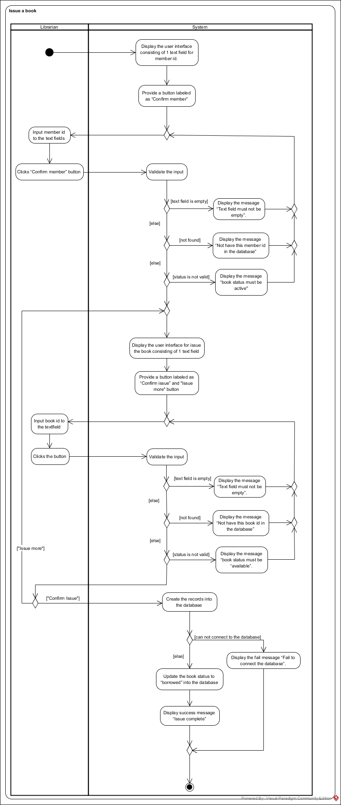Activity diagram: AD-15

|  |  |  |  |  |
| --- | --- | --- | --- | --- |
| Use Case ID | UC-16 | | | |
| Use Case Name | Update a record. | | | |
| Created By | Mr. Pasakorn Kunchai | | Last Update By | Mr. Pasakorn Kunchai |
| Date Created | 17-04-2017 | | Last Revision Date | 22-04-2017 |
| Actors | Librarian. | | | |
| Description | The librarian can update the records of a book into the database, which is member id, book id, issue date, return date, rental price and fine. | | | |
| Trigger | The librarian click “Update record” button next to the information of records. | | | |
| Preconditions | The librarian clicked view all records at home page. | | | |
| Use Case Input Specification | | | | |
| Input | type | Constraint | | Example |
| member id | String | Numeric input | | 214 |
| book id | String | Numeric input | | 1204 |
| issue date | Date | Date format | | 17-04-2017 10:30:00 |
| return date | Date | Date format | | 17-04-2017 10:30:00 |
| rental price | Double | Decimal number with 2 decimal digits | | 5.00 |
| fine | Double | Decimal number with 2 decimal digits | | 60.00 |
| Post conditions | If the use case is successful, the record is updated and stored in the database. If not the system return to home page. | | | |
| Normal Flows | User | | System | |
| 1. |  | | The system displays the user interface for updating the record consisting 6 text fields, which are member id, book id, issue date, return date, rental price and fine. | |
| 2. |  | | The “Update record” changes to “Confirm update” button. | |
| 3. | The librarian input information for updating. | |  | |
| 4. | The librarian clicks “Confirm update” button. | |  | |
| 5. |  | | The system shall validate the input. [A1: member id is in the wrong format], [A2: book id is in the wrong format], [A3: issue date is in the wrong format], [A4: return date is in the wrong format], [A5: rental price is in the wrong format] , [A6: fine is in the wrong format]. | |
| 6. |  | | The system shall display a confirmation box with message “Are you confirm to update this record” and “Yes” button and “No” button. | |
| 7. | The librarian click “Yes” button. [E1: The librarian clicks “No” button] | |  | |
| 8. |  | | The system shall update the information of the record into the database. [E2: Database cannot be connected] | |
| 9. |  | | The system shall display the success message “The input is stored in the database” | |
| Alternative Flow | A1: member id is in the wrong format.   * The system shall display the fail message “The format of member id is not valid”. * Return to normal flows 3.   A2: book id is in the wrong format.   * The system shall display the fail message “The format of book id is not valid”. * Return to normal flows 3.   A3: issue date is in the wrong format.   * The system shall display the fail message “The format of issue date is not valid”. * Return to normal flows 3.   A4: return date is in the wrong format.   * The system shall display the fail message “The format of return date is not valid”. * Return to normal flows 3.   A5: rental price is in the wrong format.   * The system shall display the fail message “The format of rental price is not valid”. * Return to normal flows 3.   A6: fine is in the wrong format.   * The system shall display the fail message “The format of fine is not valid”. * Return to normal flows 3. | | | |
| Exception Flow | E1: The librarian clicks “No” button.   * Use case ends.   E2: Database cannot be connected.   * The system shall display the fail message “Fail to connect the database” * Use case ends. | | | |
| Assumption | The librarian must understand English. | | | |

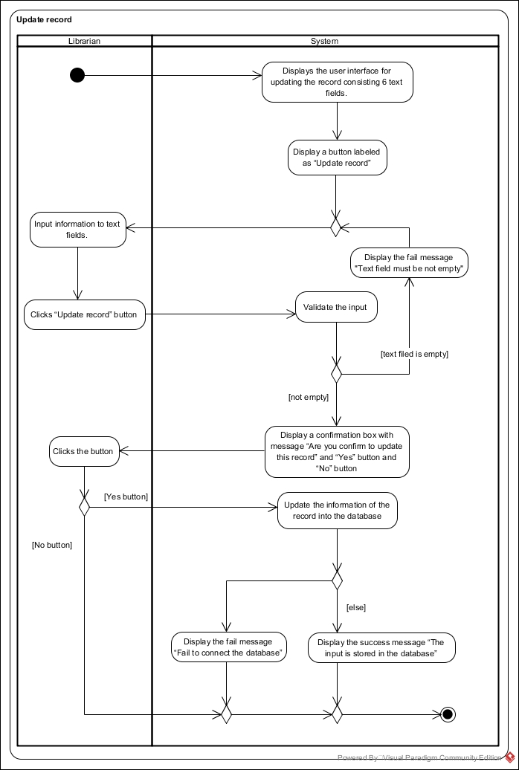Activity diagram: AD-16

|  |  |  |  |  |
| --- | --- | --- | --- | --- |
| Use Case ID | UC-17 | | | |
| Use Case Name | Return a book | | | |
| Created By | Mr. Pasakorn Kunchai | | Last Update By | Mr. Pasakorn Kunchai |
| Date Created | 15-04-2017 | | Last Revision Date | 23-04-2017 |
| Actors | Librarian | | | |
| Description | The librarian can return a book using book id. | | | |
| Trigger | The librarian clicks “Return a book” button at home page. | | | |
| Preconditions | - | | | |
| Use Case Input Specification | | | | |
| Input | type | Constraint | | Example |
| book id | String | Numeric input. | | 1028 |
| Post conditions | If the use case is successful,   * The Records in the database is updated. * Status of the book is updated to “available”   If not the system return to home page. | | | |
| Normal Flows | User | | System | |
| 1. |  | | The system shall display the user interface for issue the book consisting of 1 text fields for book id. | |
| 2. |  | | The system shall provide a button labeled as “Confirm return” for the librarian to confirm issue and do not need to want to issue more book. | |
| 3. |  | | The system shall provide a button labeled as “Return more” for the librarian to issue more book. | |
| 4. | The librarian input book id to the text fields. | |  | |
| 5. | The librarian clicks “Confirm return” button. [A1: The librarian clicks “return more”] | |  | |
| 6. |  | | The system shall validate the input. [A3: Not have this book id in the database], [A4: Text field is empty], [A5: status of the book is not valid] | |
| 7. |  | | The system shall search the book id in the records using book id for update the return date, rental price and fine in the records. [E1: Database cannot be connected] | |
| 8. |  | | The system shall update the book status to “available” into the database. | |
| 9. |  | | The system shall display success message “Return complete” when the records is stored in the database. | |
| Alternative Flow | A1: The librarian clicks “Issue more”.   * Go to normal flow 6. * Return to normal flow 1.   A2: book id is in the wrong format.   * The system shall display the fail message “The format of book id is not valid”. * Return to normal flows 4.   A3: Not have this book id in the database.   * The system shall display the fail message “Not have this book id in the database”. * Return to normal flows 4.   A4: Text field is empty.   * The system shall display the fail message “Text field must not be empty”. * Return to normal flows 4.   A5: status of the book is not valid.   * The system shall display the message “book status must be “borrowed”. * Return to normal flows 4. | | | |
| Exception Flow | E1: Database cannot be connected   * The system shall display the fail message “Fail to connect the database”. * Use case ends. | | | |
| Assumption | The Librarian must understand English. | | | |

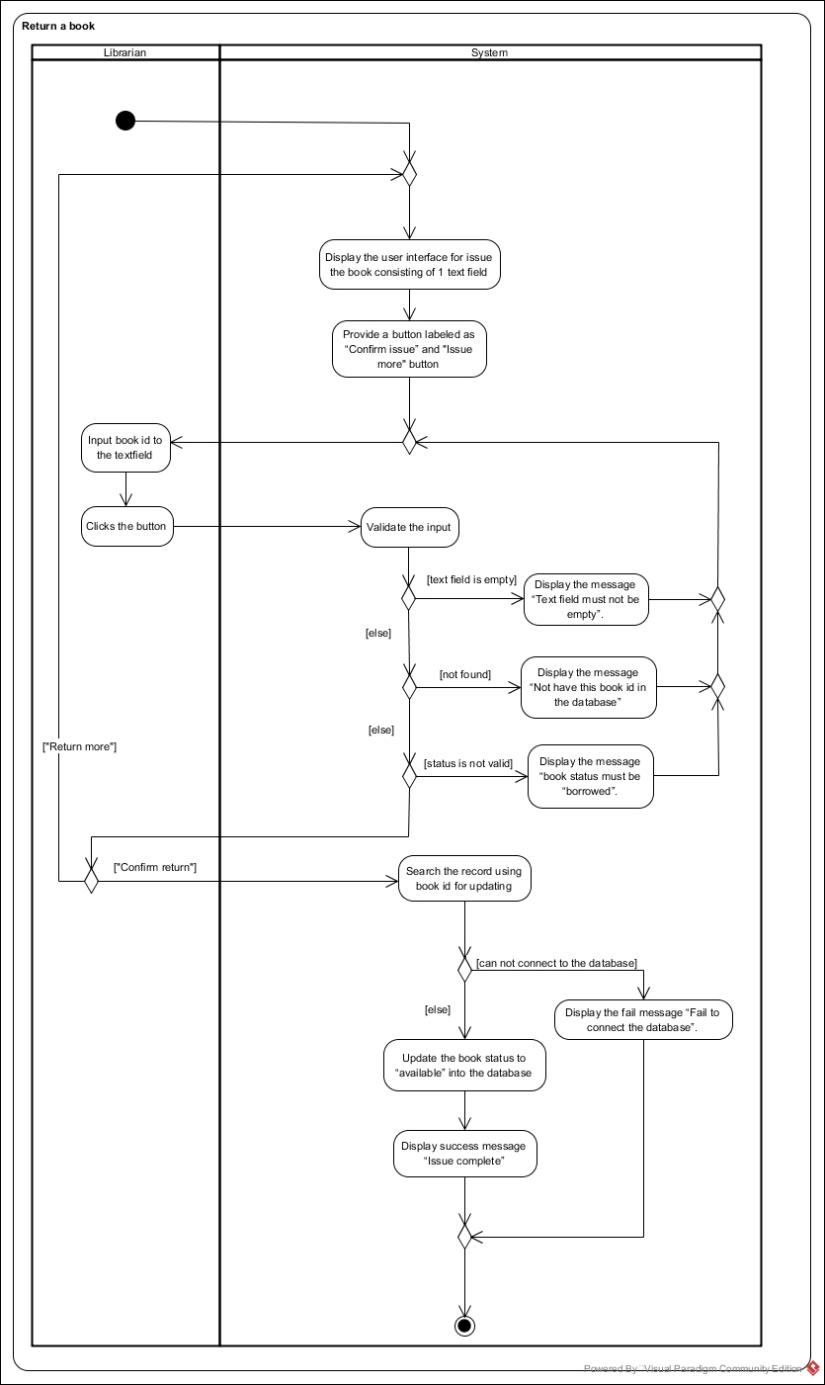Activity diagram: AD-17

|  |  |  |  |  |
| --- | --- | --- | --- | --- |
| Use Case ID | UC-18 | | | |
| Use Case Name | Search a record. | | | |
| Created By | Mr. Pasakorn Kunchai | | Last Update By | Mr. Pasakorn Kunchai |
| Date Created | 17-04-2017 | | Last Revision Date | 23-04-2017 |
| Actors | Librarian | | | |
| Description | The librarian can search a record from the database using keyword and option. | | | |
| Trigger | The librarian clicks “Search a record” button at home page. | | | |
| Preconditions | - | | | |
| Use Case Input Specification | | | | |
| Input | type | Constraint | | Example |
| keyword | String | Length must not exceed 50 characters. | | 1234 |
| option | String | Select one of this set [record number, book id, issue date, return date, rental price and fine]. | | book id |
| Post conditions | If the use case is successful, At least one record is displayed. If not the system return to home page. | | | |
| Normal Flows | User | | System | |
| 1. |  | | The system shall display the user interface for search the book consisting of 1 text field for keyword. | |
| 2. |  | | The system provides options to search, which are record number, member id, book id, issue date, return date, rental price and fine. | |
| 3. |  | | The system shall display a button labeled as “Search record.” | |
| 4. | The librarian input keyword to the text field. | |  | |
| 5. | The librarian select the options. | |  | |
| 6. | The librarian clicks “Search record” button. | |  | |
| 7. |  | | The system shall validate the input. [A1: keyword is wrong in format] | |
| 8. |  | | The system shall retrieve the list of record using keyword and option in the record number, member id, book id, issue date, return date, rental price and fine into the database. [A2: record is not matched with the keyword], [E1: There is no record in the database]. [E2: Database cannot be connected] | |
| 9. |  | | The system shall display the list of record when there is at least one record that matches with the keyword. | |
| Alternative Flow | A1: keyword is wrong in format.   * The system shall display the fail message next to the keyword text fields “The format of keyword is not valid”. * Return to normal flows 4.   A2: record is not matched with the keyword.   * The system shall display the message “There is no record matched with the keyword” * Return to normal flows 4. | | | |
| Exception Flow | E1: There is no record in the database.   * The system shall display the message “There is no record in the database” * Use case ends.   E2: Database cannot be connected.   * The system shall display the fail message “Fail to connect the database”. * Use case ends. | | | |
| Assumption | The Librarian must understand English. | | | |

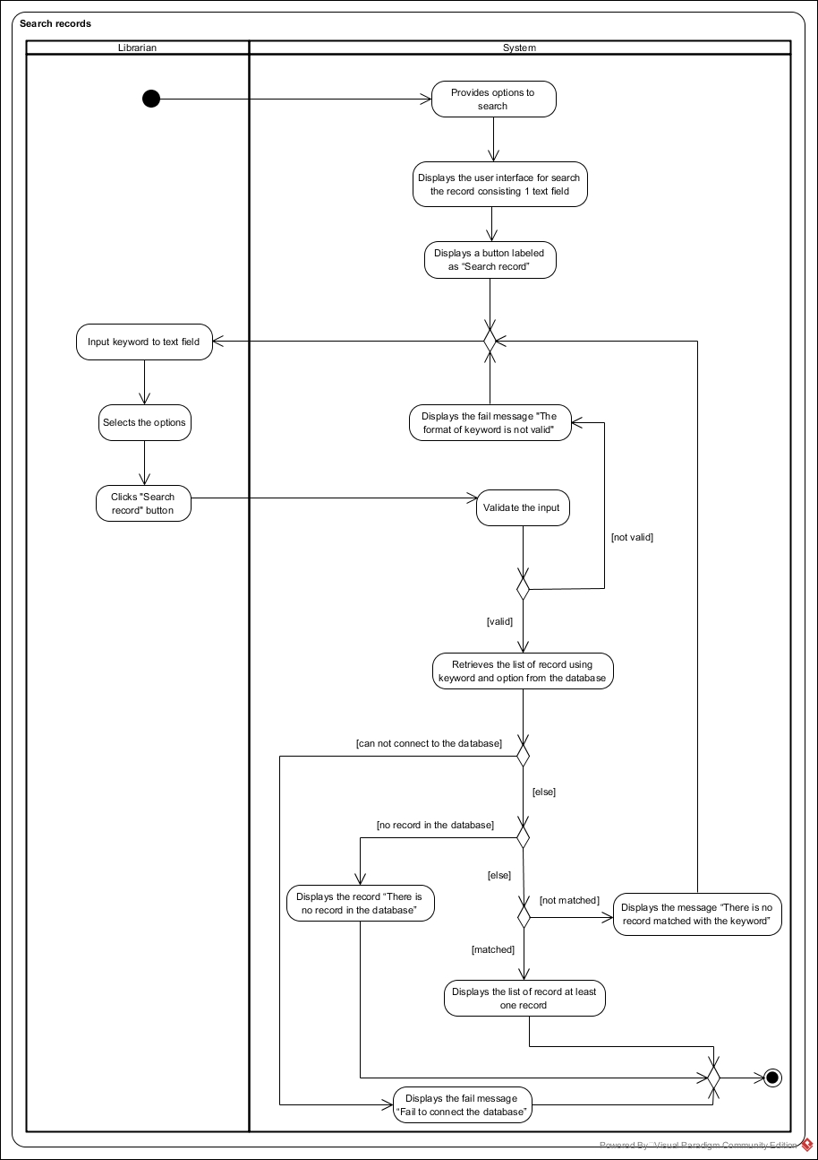Activity diagram: AD-18

|  |  |  |  |  |
| --- | --- | --- | --- | --- |
| Use Case ID | UC-19 | | | |
| Use Case Name | View all of records. | | | |
| Created By | Mr. Pasakorn Kunchai | | Last Update By | Mr. Pasakorn Kunchai |
| Date Created | 17-04-2017 | | Last Revision Date | 22-04-2017 |
| Actors | Librarian | | | |
| Description | The library can view all of records in the system. | | | |
| Trigger | The librarian clicks “View all records” button at home page. | | | |
| Preconditions | - | | | |
| Use Case Input Specification | | | | |
| Input | type | Constraint | | Example |
| - | - | - | | - |
| Post conditions | If the use case is successful, the list of record is displayed. If not the system return to home page. | | | |
| Normal Flows | User | | System | |
| 1. |  | | The system shall be able to get the list of records from the database [E1: there are not records in the database.], [E2: Database cannot be connected.] | |
| 2. |  | | The system shall provide an interface, which display the list of records, which are record number, book id, issue date, return date, rental price and fine. | |
| Alternative Flow | - | | | |
| Exception Flow | E1: there are not records in the database.   * The system shall display message “There are not records in the database”. * Use case ends.   E2: Database cannot be connected.   * The system shall display the fail message “Fail to connect the database”. * Use case ends. | | | |
| Assumption | The librarian must understand English. | | | |

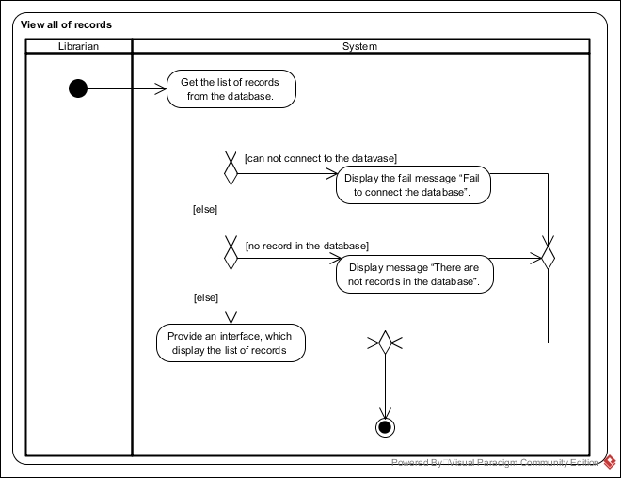Activity diagram: AD-19

|  |  |  |  |  |
| --- | --- | --- | --- | --- |
| Use Case ID | UC-20 | | | |
| Use Case Name | Remove a record. | | | |
| Created By | Mr. Pasakorn Kunchai | | Last Update By | Mr. Pasakorn Kunchai |
| Date Created | 17-4-2017 | | Last Revision Date | 22-04-2017 |
| Actors | Librarian | | | |
| Description | The librarian can remove a record from the database. | | | |
| Trigger | The librarian clicks “Delete record” button. | | | |
| Preconditions | The librarian clicked “View all of records” button already. | | | |
| Use Case Input Specification | | | | |
| Input | type | Constraint | | Example |
| - | - | - | | - |
| Post conditions | If the use case is successful, the record was deleted from the database. If not the system return to home page | | | |
| Normal Flows | User | | System | |
| 1. |  | | The system shall display a button labeled as “Delete record” next to the information of records. | |
| 2. | The librarian clicks “Delete record” button. | |  | |
| 3. |  | | The system shall display a confirmation box with message “Are you confirm to deleted this record” and “Yes” button and “No” button. | |
| 4. | The librarian clicks “Yes” button. [E1: The librarian clicks “No” button] | |  | |
| 5. |  | | The system shall delete the record from the database. [E2: Database cannot be connected] | |
| Alternative Flow | - | | | |
| Exception Flow | E1: The librarian clicks “No” button.   * Use case ends.   E2: Database cannot be connected.   * The system shall display the fail message “Fail to connect the database”. * Use case ends. | | | |
| Assumption | The librarian must understand English. | | | |

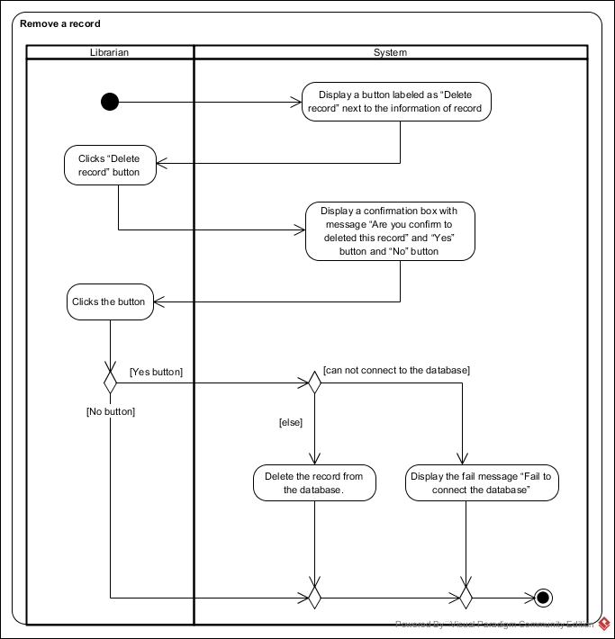Activity diagram: AD-20

Class diagram

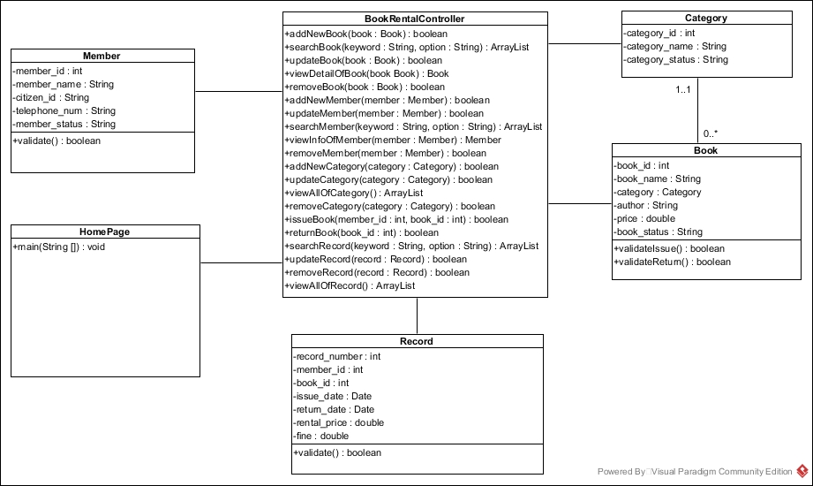1.Book Rental System Class Diagram(Overview)

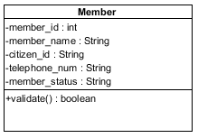

Attributes:

|  |  |  |  |  |
| --- | --- | --- | --- | --- |
| No. | Name | Description | Access Modifier | Data Type |
| 1. | member_id | The unique identifier of member. | Private | int |
| 2. | member_name | Name of member. | Private | String |
| 3. | citizen_id | Citizen ID of member. | Private | String |
| 4. | telephone_num | Telephone number of member. | Private | String |
| 5. | member_status | Status of member, which are active or not active. | Private | String |

Methods:

|  |  |  |  |  |  |
| --- | --- | --- | --- | --- | --- |
| No. | Name | Description | Access Modifier | Input Arguments | Return Type |
| 1. | validate | Verify status of member. If the status is “active”, it will return true. Otherwise, it will return false | Public | - | boolean |

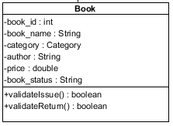

Attributes:

|  |  |  |  |  |
| --- | --- | --- | --- | --- |
| No. | Name | Description | Access Modifier | Data Type |
| 1. | book_id | The unique identifier of book. | Private | int |
| 2. | book_name | Name of book. | Private | String |
| 3. | category | Category of book | Private | Category |
| 4. | author | Author of book | Private | String |
| 5. | price | Price for rental the book | Private | double |

Methods:

|  |  |  |  |  |  |
| --- | --- | --- | --- | --- | --- |
| No. | Name | Description | Access Modifier | Input Arguments | Return Type |
| 1. | validateIssue | Verify status of book for issuing. If the status is “available”, it will return true. Otherwise, it will return false | Public | - | boolean |
| 2. | validateReturn | Verify status of book for issuing. If the status is “borrowed”, it will return true. Otherwise, it will return false | Public | - | boolean |

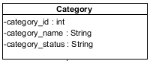

Attributes:

|  |  |  |  |  |
| --- | --- | --- | --- | --- |
| No. | Name | Description | Access Modifier | Data Type |
| 1. | category_id | The unique identifier of category. | Private | int |
| 2. | category_name | Name of category. | Private | String |
| 3. | category_status | Status of category. | Private | String |

Methods:

|  |  |  |  |  |  |
| --- | --- | --- | --- | --- | --- |
| No. | Name | Description | Access Modifier | Input Arguments | Return Type |
| - | - | - | - | - | - |

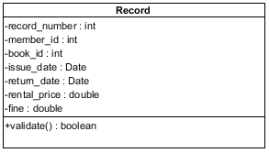

Attributes:

|  |  |  |  |  |
| --- | --- | --- | --- | --- |
| No. | Name | Description | Access Modifier | Data Type |
| 1. | record_number | The unique identifier of record. | Private | int |
| 2. | member_id | The unique identifier of member. | Private | int |
| 3. | book_id | The unique identifier of book. | Private | int |
| 4. | issue_date | Date that issue the book. | Private | Date |
| 5. | return_date | Date that return the book. | Private | Date |
| 6. | rental_price | Price of rental | Private | double |
| 7. | fine | Fine of rental | Private | double |

Methods:

|  |  |  |  |  |  |
| --- | --- | --- | --- | --- | --- |
| No. | Name | Description | Access Modifier | Input Arguments | Return Type |
| 1. | validate | Verify the correctness of record | Public | - | boolean |

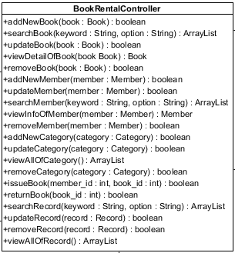

Attributes:

|  |  |  |  |  |
| --- | --- | --- | --- | --- |
| No. | Name | Description | Access Modifier | Data Type |
| - | - | - | - | - |

Methods:

|  |  |  |  |  |  |
| --- | --- | --- | --- | --- | --- |
| No. | Name | Description | Access Modifier | Input Arguments | Return Type |
| 1. | addNewBook | Add book’s data to the database | Public | book : Book | boolean |
| 2. | searchBook | Search book form the database by using keyword and option. | Public | keyword : String, option : String | ArrayList |
| If the keyword does not match. | Null |
| 3. | updateBook | Update book’s data to the database | Public | book : Book | boolean |
| 4. | viewDetailOfBook | View book’s data from the database | Public | book : Book | Book |
| 5. | removeBook | Update book status becomes to “removed” to the database | Public | book : Book | boolean |
| 6. | addNewMember | Add member’s data to the database | Public | member : Member | boolean |
| 7. | searchMember | Search member form the database by using keyword and option. | Public | keyword : String, option : String | ArrayList |
| If the keyword does not match. | Null |
| 8. | updateMember | Update member’s data to the database | Public | member : Member | boolean |
| 9. | viewInfoOfMember | View member’s data from the database | Public | member : Member | Member |
| 10. | removeMember | Update member status becomes to “not active” to the database | Public | member : Member | boolean |
| 11. | addNewCategory | Add category’s data to the database | Public | category : Category | boolean |
| 12. | updateCategory | Update category’s data to the database | Public | category : Category | boolean |
| 13. | viewAllOfCategory | View all category’s data from the database | Public | - | ArrayList |
| 14. | removeCategory | Update category status becomes to “not active” to the database | Public | category : Category | boolean |
| 15. | issueBook | Create record of issuing and update the book status to “borrowed” to the database | Public | member_id : int, book_id : int | boolean |
| 16. | returnBook | Update record of issuing and update the book status to “available” to the database | Public | book_id : int | boolean |
| 17. | updateRecord | Update record’s data to the database | Public | record : Record | boolean |
| 18. | searchRecord | Search record form the database by using keyword and option. | Public | keyword : String, option : String | ArrayList |
| If the keyword does not match | Null |
| 19. | viewAllOfRecord | View all record’s data from the database | Public | - | ArrayList |
| 20. | removeRecord | Remove record’s data from the database | Public | record : Record | boolean |

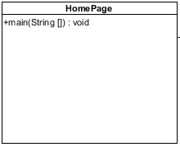

Attributes:

|  |  |  |  |  |
| --- | --- | --- | --- | --- |
| No. | Name | Description | Access Modifier | Data Type |
| - | - | - | - | - |

Methods:

|  |  |  |  |  |  |
| --- | --- | --- | --- | --- | --- |
| No. | Name | Description | Access Modifier | Input Arguments | Return Type |
| 1. | main | Used to run the system. | Public | String [] | void |

Sequence diagram

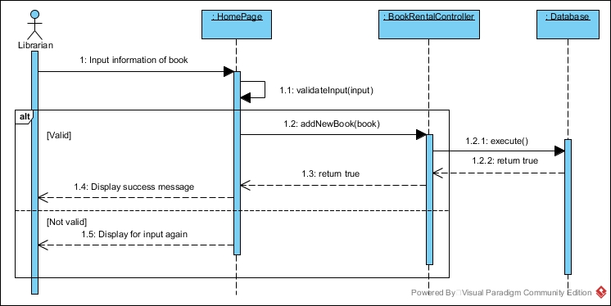SD-01: Add a new book

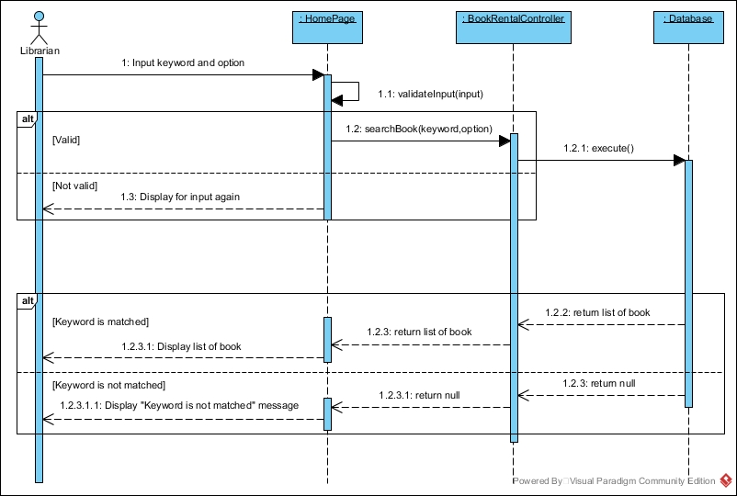SD-02: Search for a book

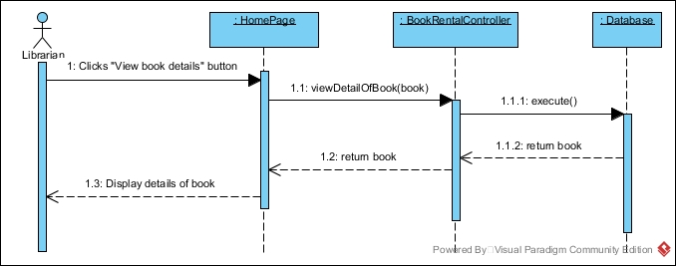SD-03: View details of a book

SD-04: Update details of a book

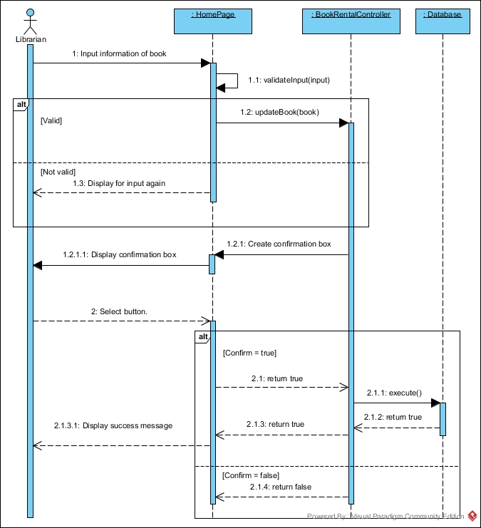

SD-05: Remove a book

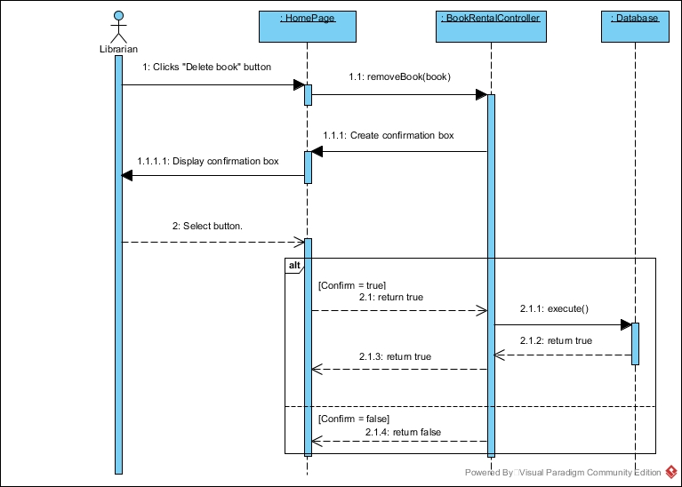

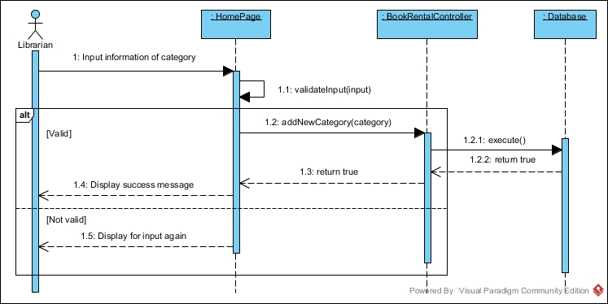SD-06: Create a new category

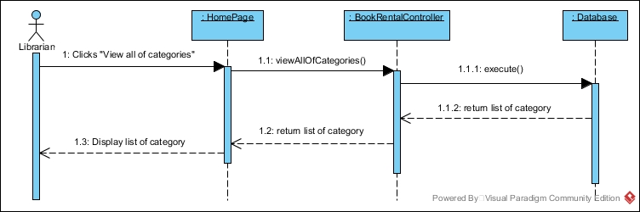SD-07: View all of category

SD-08: Update categories

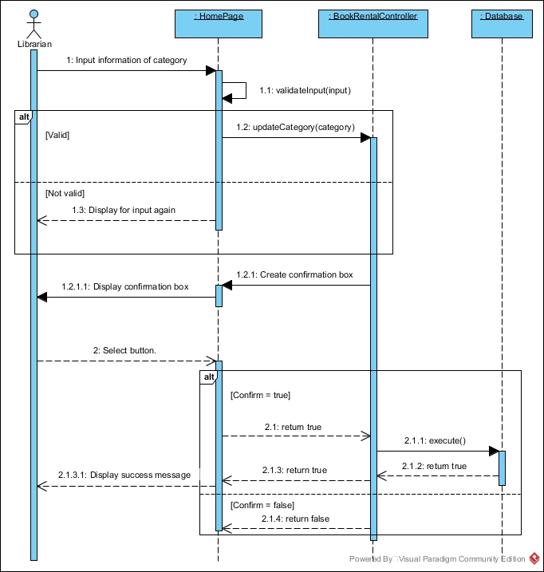

SD-09: Remove category

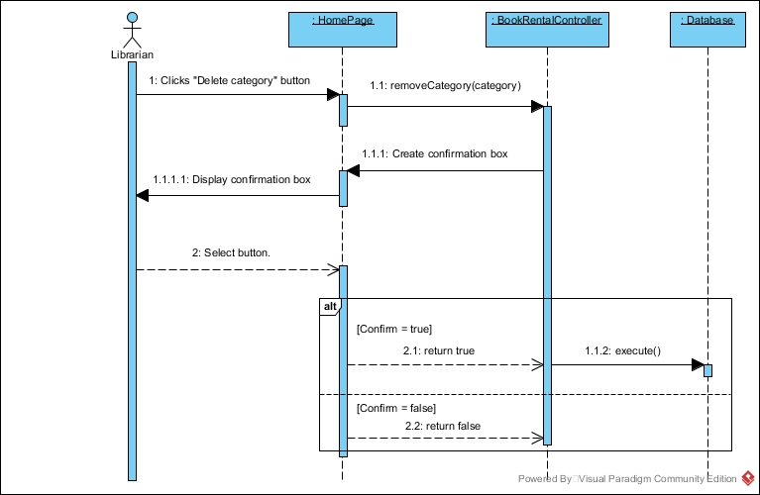

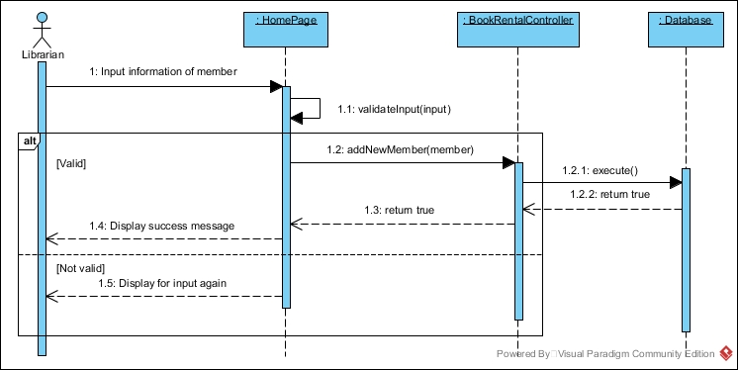SD-10: Add a new member

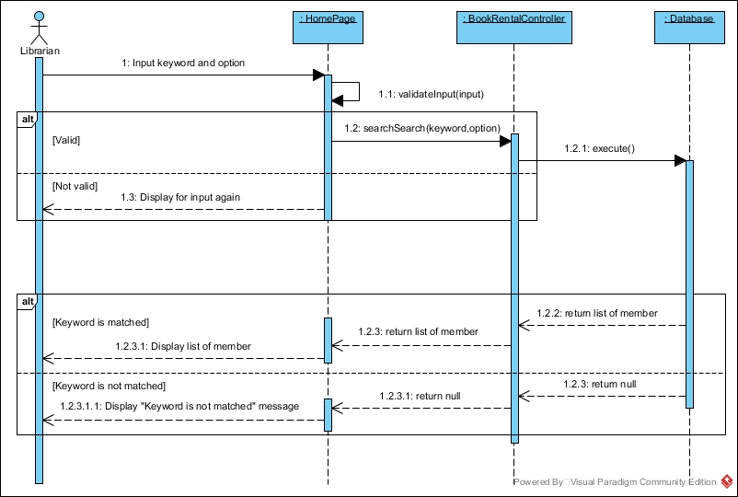SD-11: Search for a member

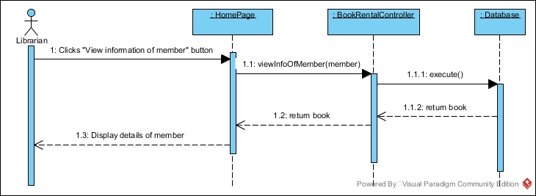SD-12: View member’s information

SD-13: Update member’s information

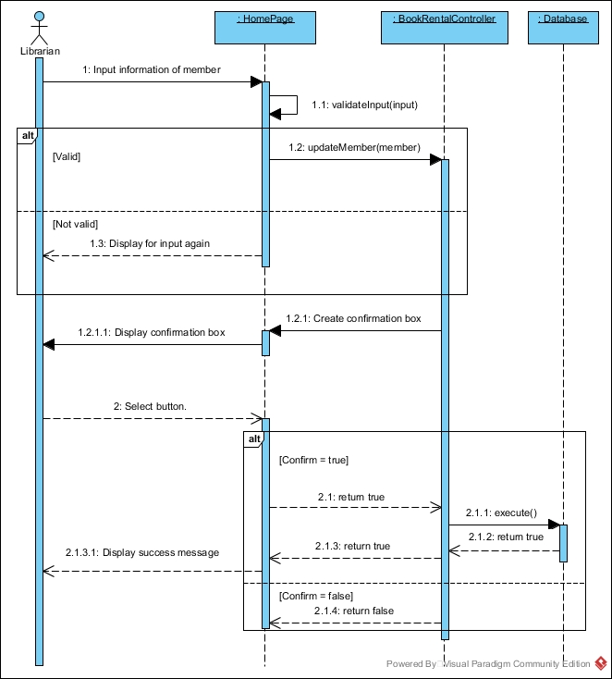

SD-14: Remove a member

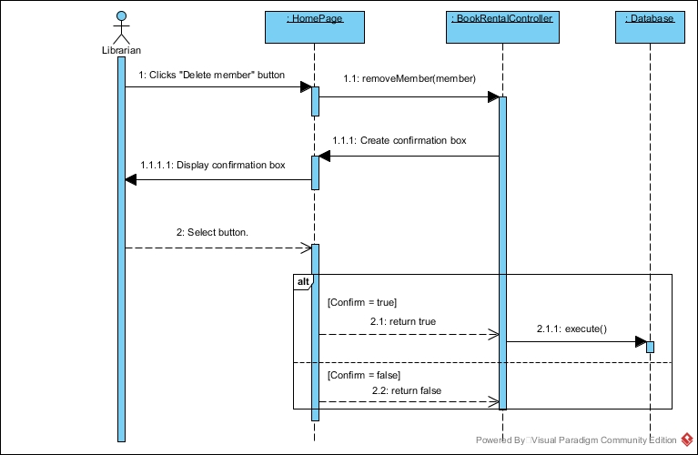

SD-15: Issue a book

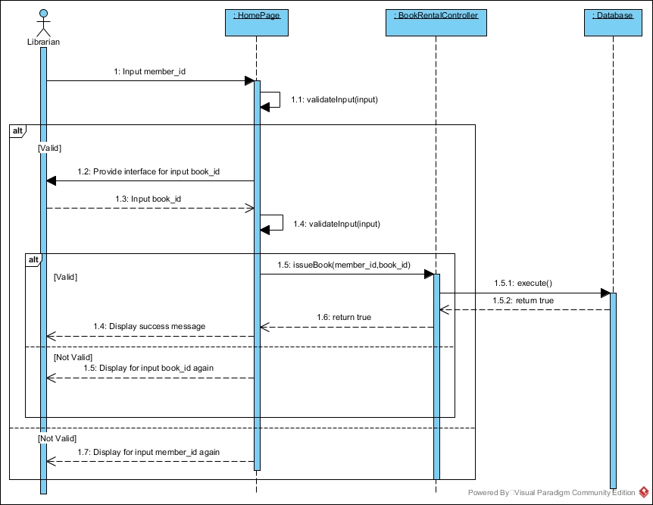

SD-16: Update record

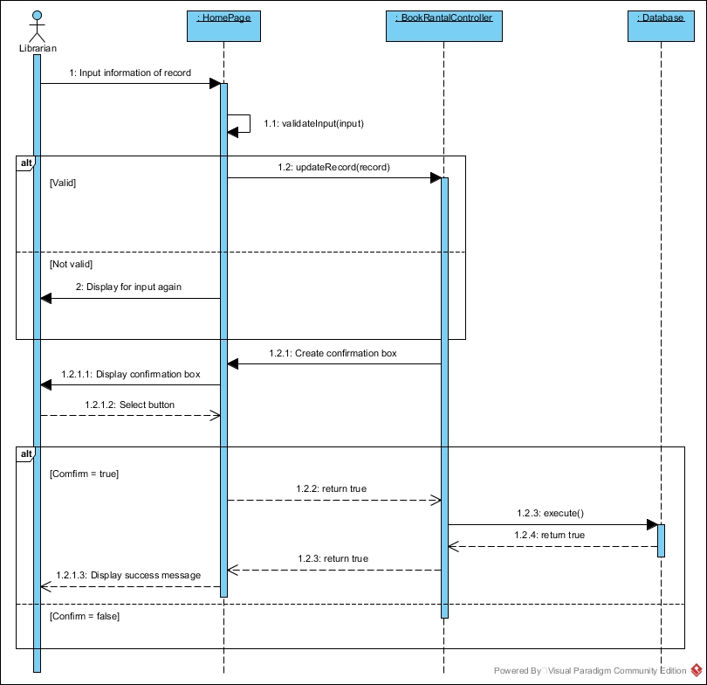

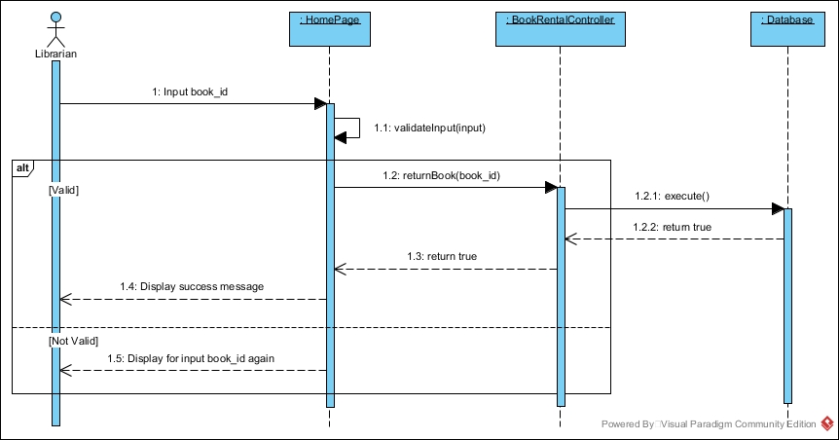SD-17: Return a book

SD-18: Search records

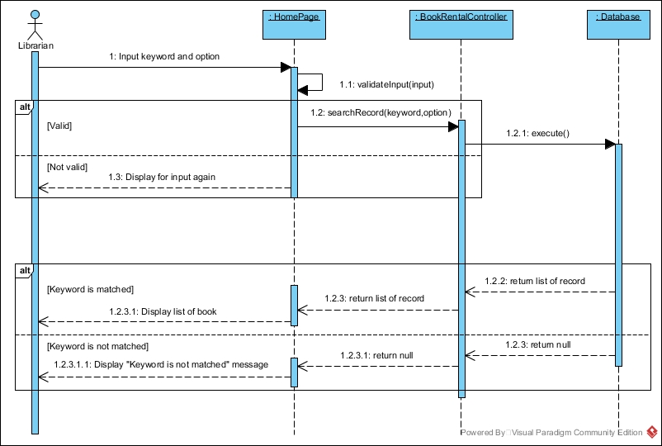

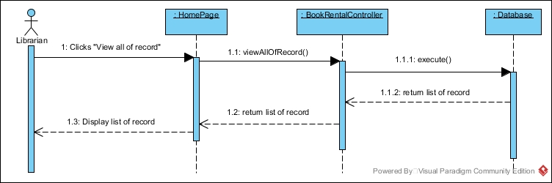SD-19: View all of records

SD-20: Remove a record

